**Module 8, Option 2: Creating The data warehouse for Islandsunset.art**

David Reese

Colorado State University Global

MIS 541: Data Warehousing in Enterprise Environments

Ofori Boateng Ph.D.

September 4, 2020

**Module 8, Option 2: Creating The data warehouse for Islandsunset.art**

For the past several weeks, I have been building the data warehouse layout for a start up company focused on selling art images in an e-commerce format. In this paper, I will be reviewing the final version of the data fact and dimension tables for the project, changes that were made, and the reasons behind some of the changes made.

To help with designing the project, I approached the project with the idea, ‘if someone called with an issue what would I want to know.’ I took this approach after reviewing the chart from the Kimball Lifecycle diagram. The diagram lays out the process of developing not only the data base, but the hardware set up as well. For the purposes of this project, the focus will be on the fact and dimension tables, involved in the project planning and Business Requirements section. The table below shows the entire process.

**Figure 1**

***Kimball Lifecycle Diagram. (Kimball & Ross, 2013 pg. 404)***

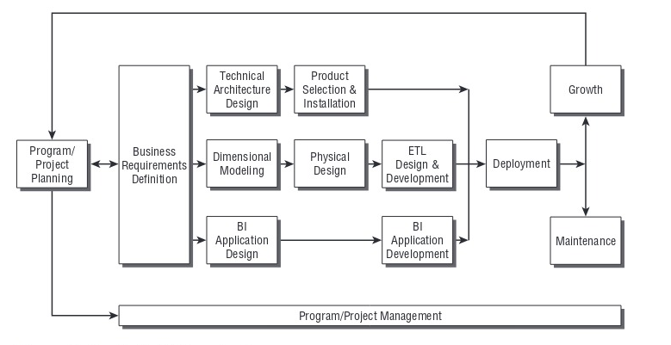

The project has completed the steps for planning and business requirement definition. The design of the tables went through a number of changes in the past weeks as every effort was made to create the cleanest possible data frame work that holds the most information possible. This will allow for faster query response times and ease of use.

Since the last report, the number of tables has been reduced from 13 to 10. Some tables were deleted most were combined into existing dimension tables. These changes were made with a focus on making the overall model easier to work with. A major change was the removal of the SKU tables. The number of possible combinations made SKU’s a data nightmare. If we are marketing 100 images, with 8 different types of finishes, on 15 different formats, the total possible SKUS would be 12,000. Instead, the company has decided to use order ID numbers generated by the various vendors as a substitute. Storage of the orders as PDF’s will be much easier to deal with in the long run when research of a problem is needed.

The ETL process was achieved by collecting, in a master data sheet, all the information on an order form. From there, dimension tables were developed based on what the order form needed to be complete. The goal was to capture as much information about each client as possible.

After the master sheet was created and populated, the various columns were exported to the dimension tables as needed. The completed spreadsheets were then saved as CSV files and imported into the system.

The new system is shown on the following page. The order fact table consists of primary keys from the various dimensions and was built around answering the question from paragraph one of this report.

**Figure 2**

***Dimension and fact tables for Islandsunset.art.***

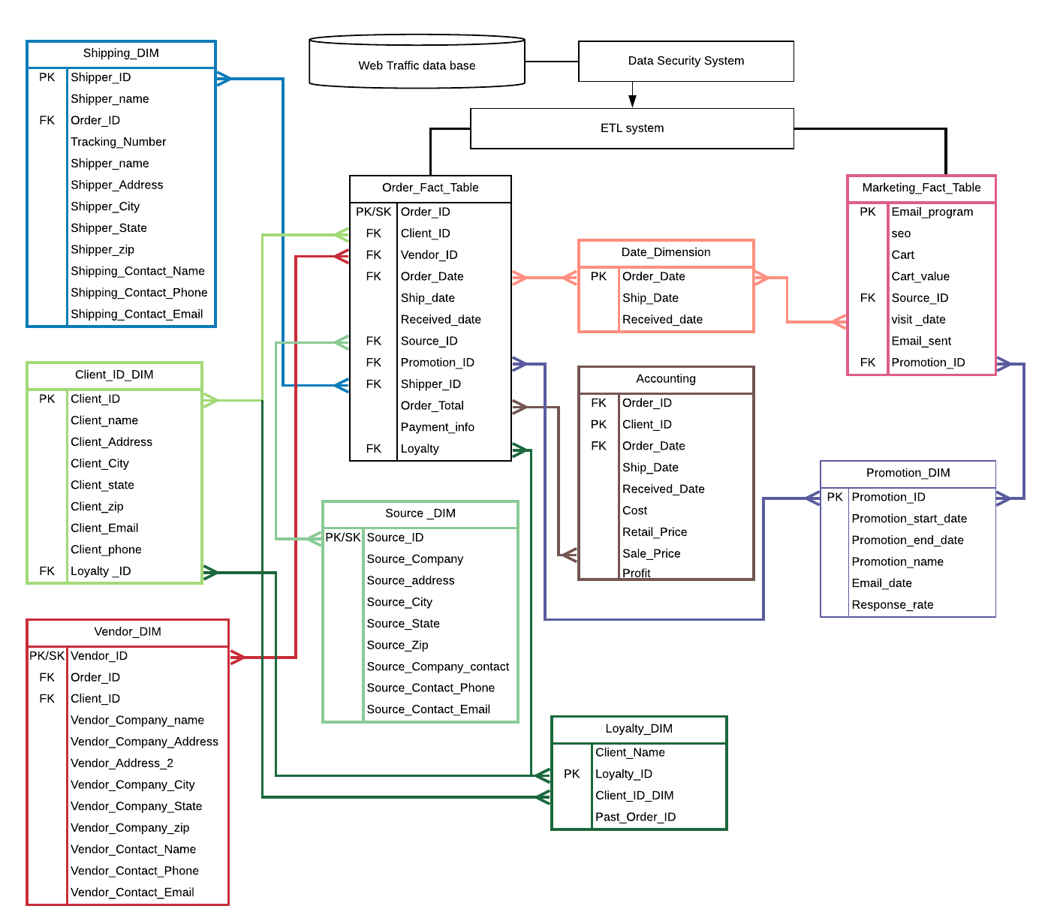

The result of the changes made will allow for information to be easier to access and respond to. To make sure the tables were functioning properly, data was loaded into each one. To generate the row count the following code was used: Select Count (*) from [*table name*];

**Figure 3**

***Accounting Dimension Table***

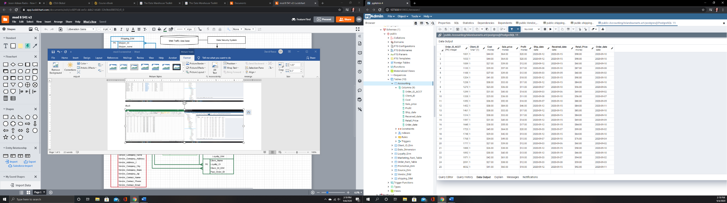

**Figure 4**

***Row Count for Accounting Dimension Table*** 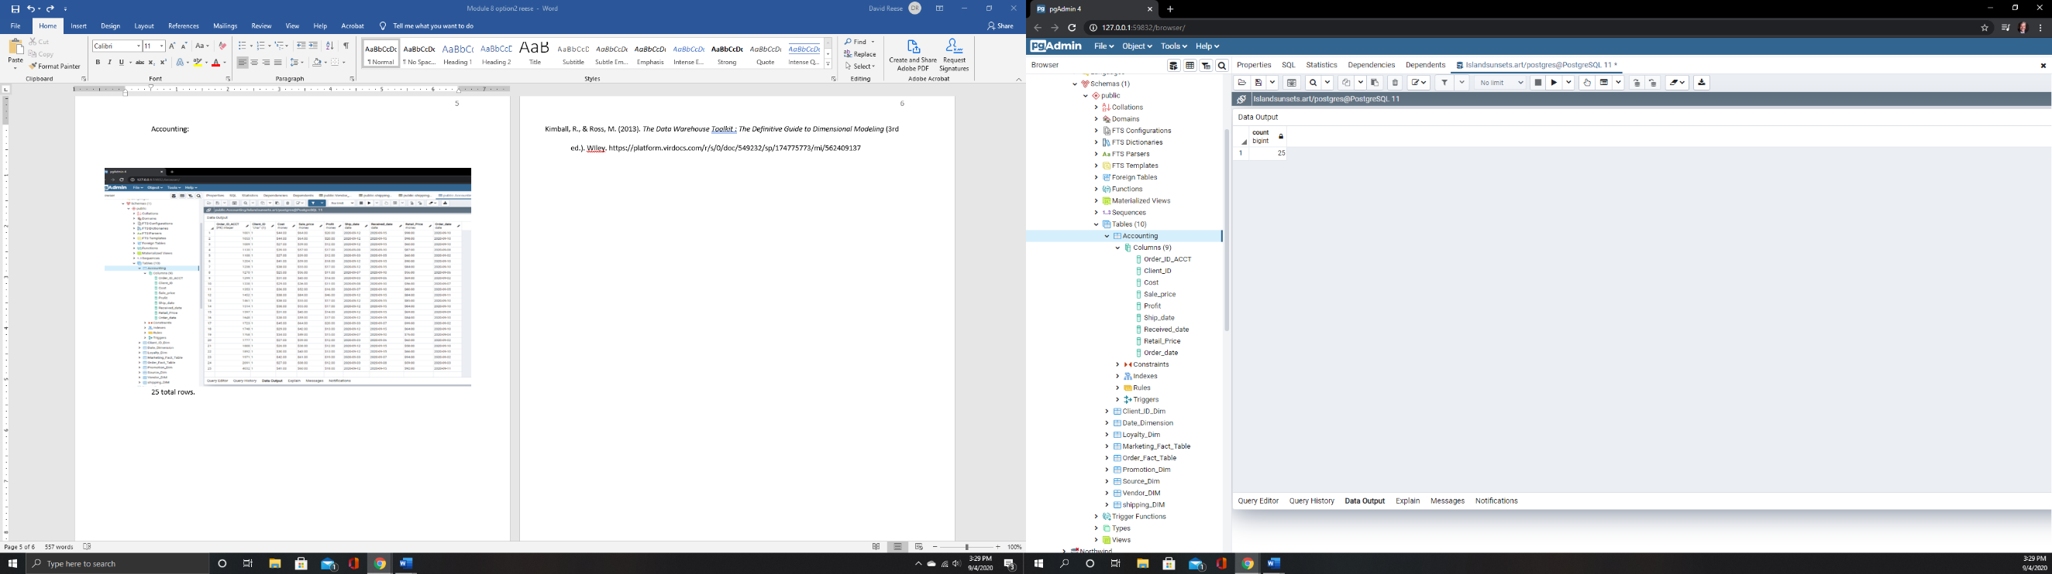

Client ID dimension tells the company everything related to the client. This table will be a key piece going forward for analysis.

**Figure 5**

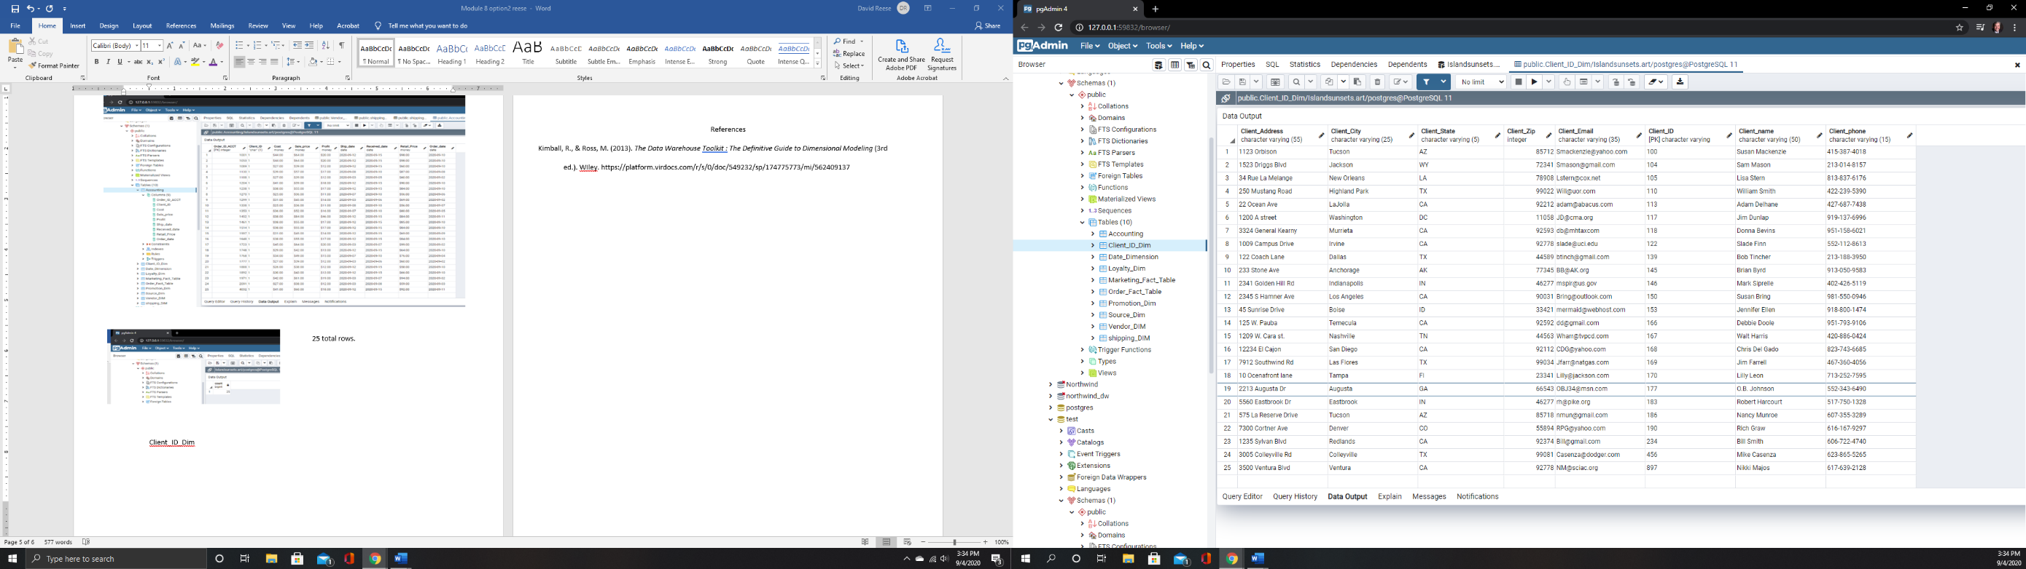***Client ID Dimension Table***

**Figure 6**

***Client ID Dimension Row Count***

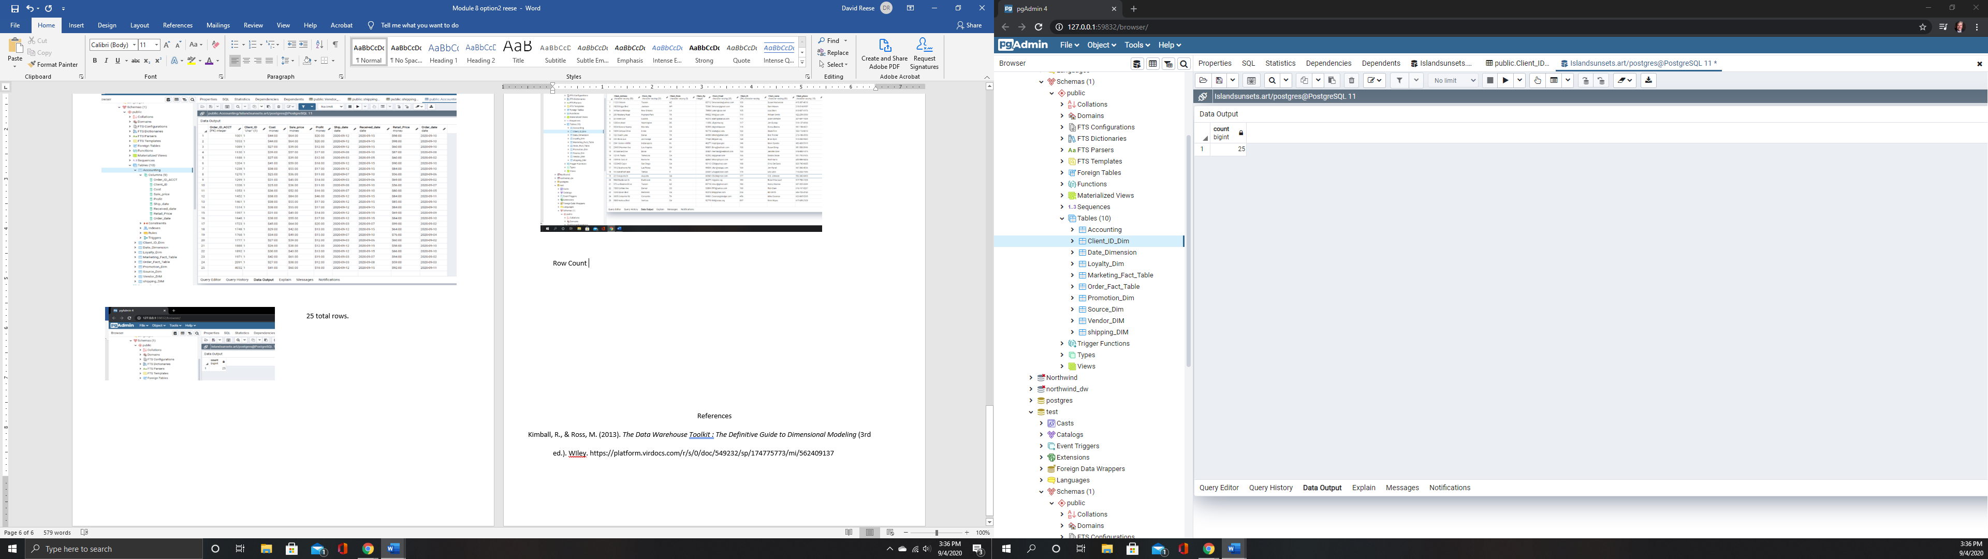

**Figure 7**

***Date Dimension Table.***

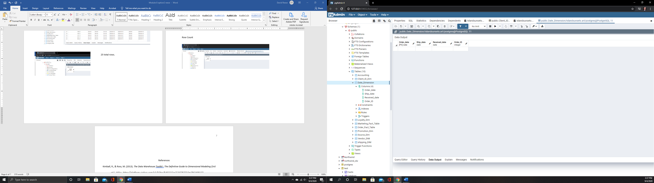

In the date dimension table, no data was input. It is there to give the entire system a sense of time.

The loyalty dimension is for a ‘frequent shopper’ type program. It will let the company know who has made repeated purchases so the company can offer discounts or free items as a reward.

**Figure 8**

**Loyalty Dimension Table**

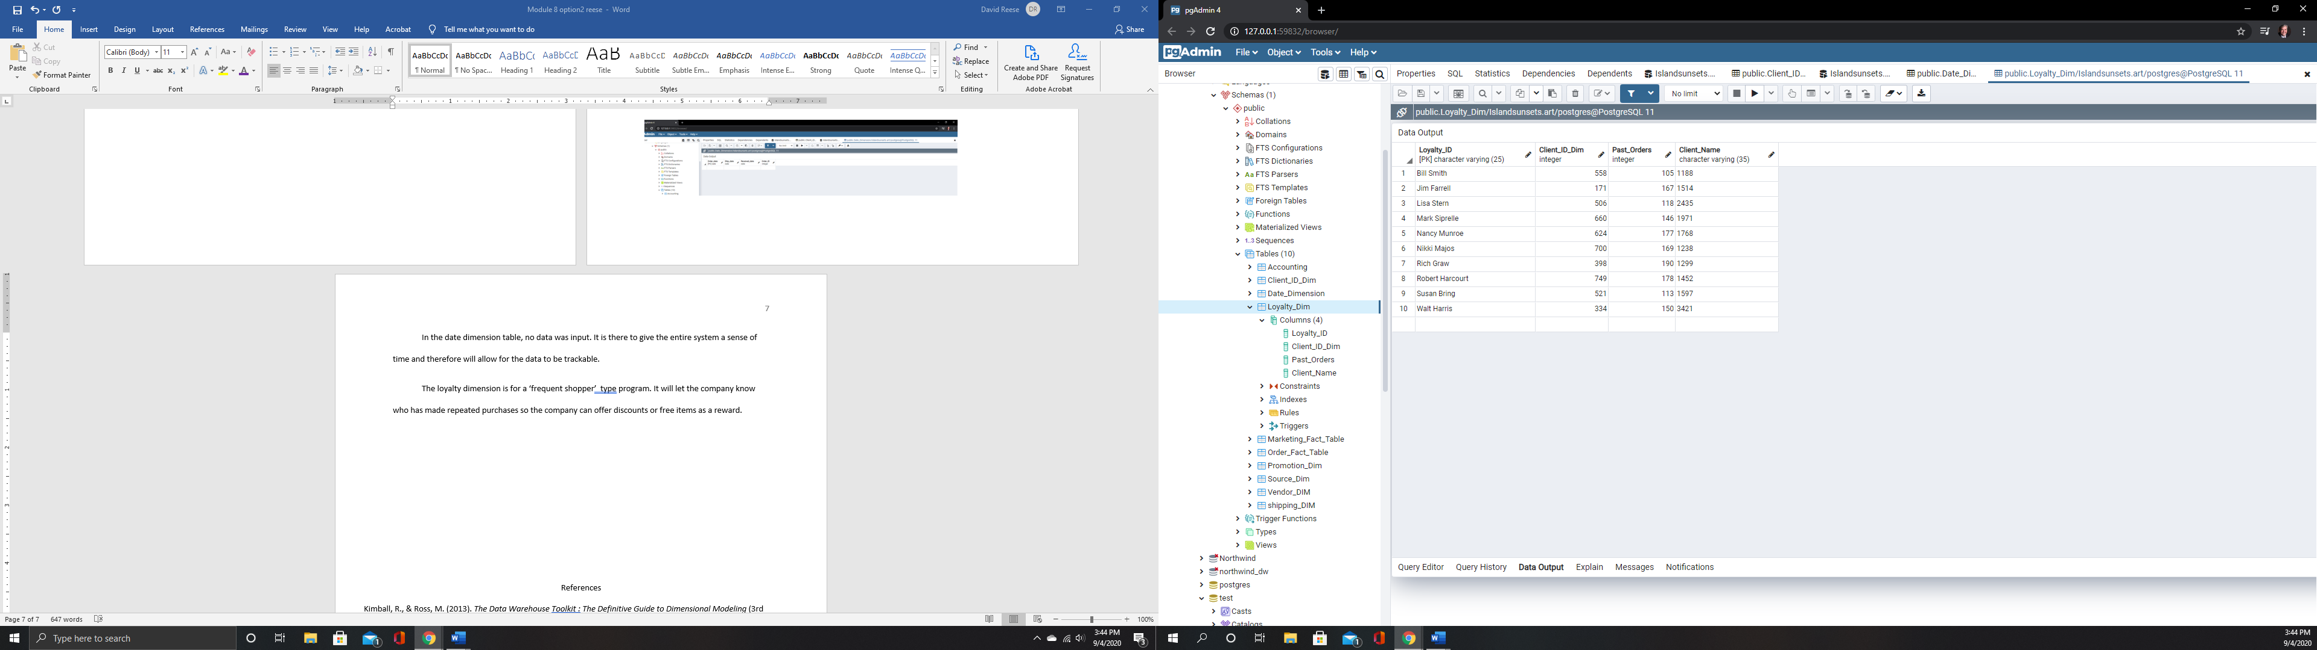

**Figure 9**

***Row count for Loyalty Dimension Table.***

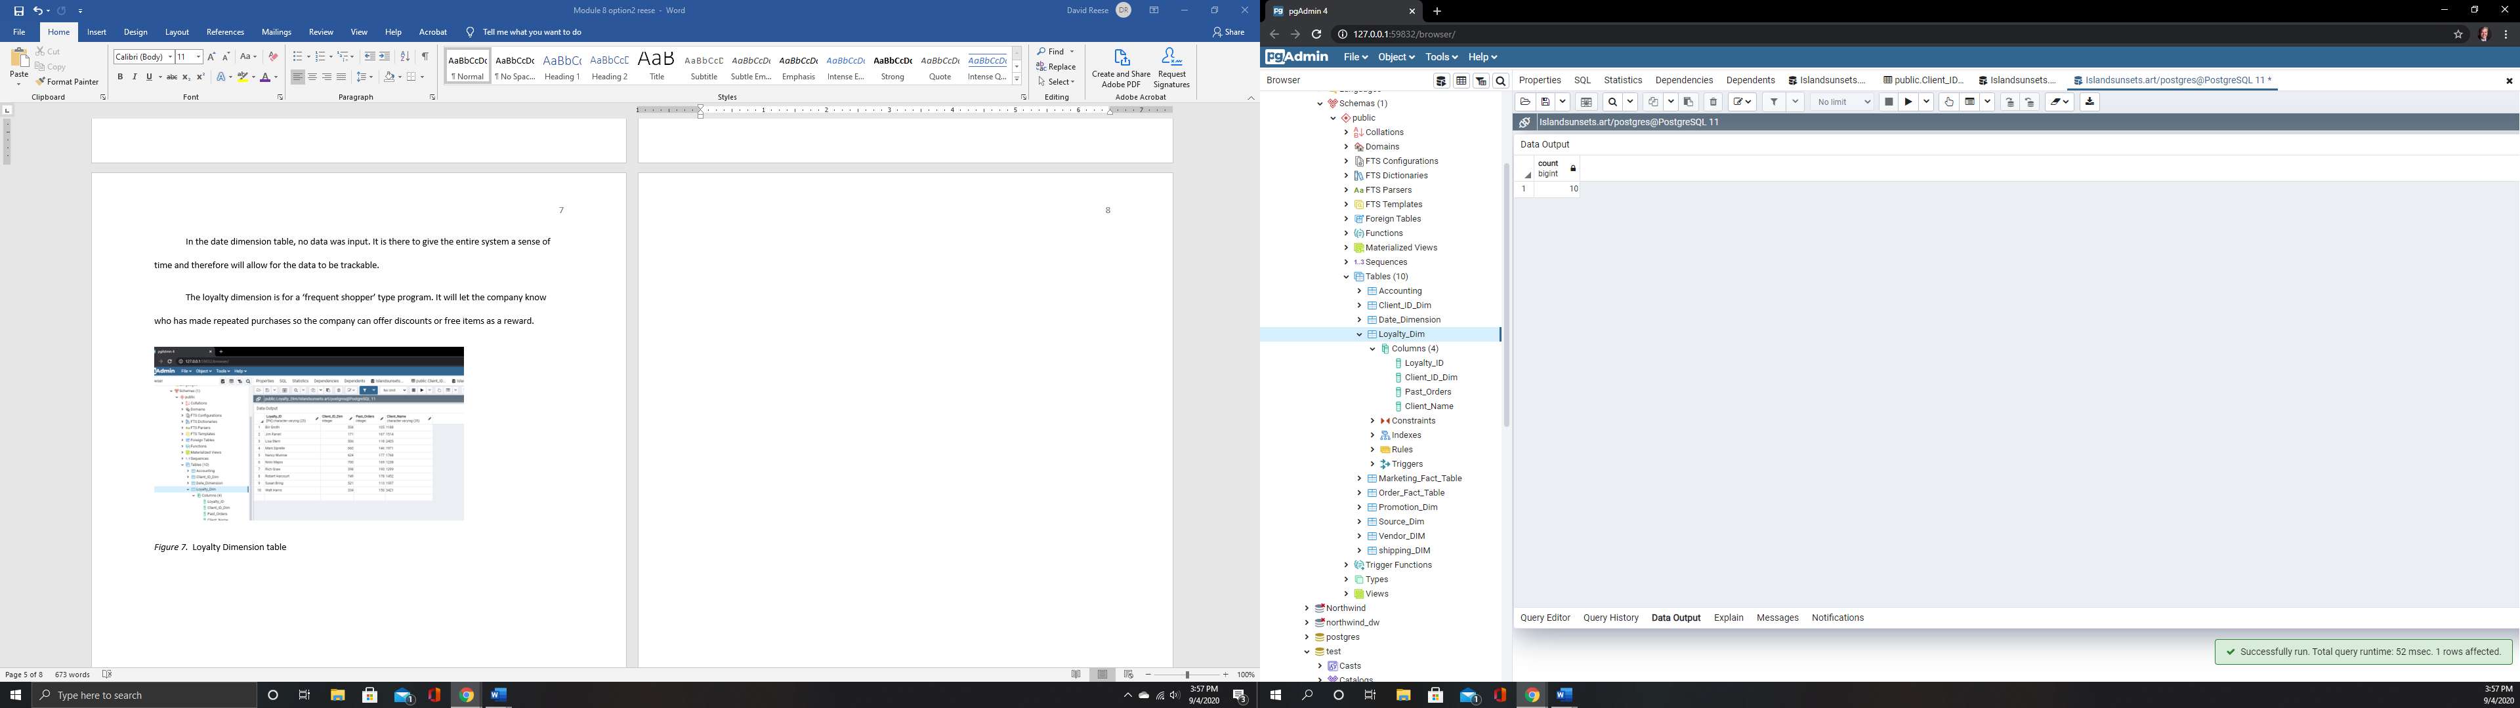

The Marketing Dimension Table includes data from web visits, wether or not the visit resulted in a shopping cart, promotions that were offered and other needed information.

**Figure 10**

***Marketing Dimension Table with successful import notification*.**

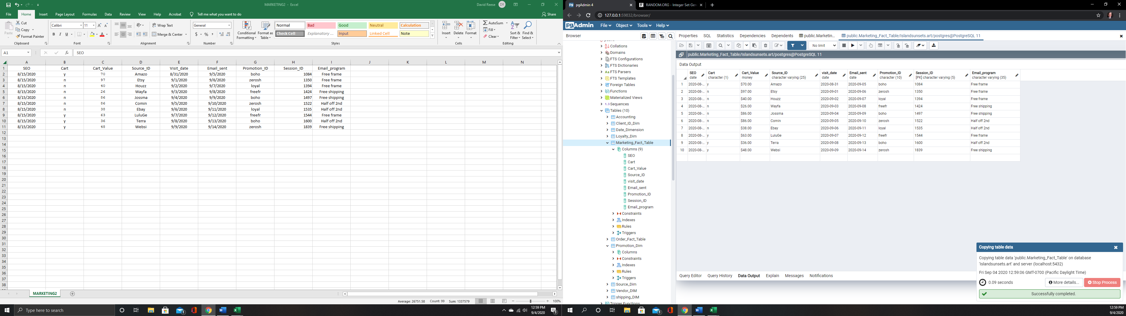

**Figure 11**

***Marketing Dimension Table row count*.**

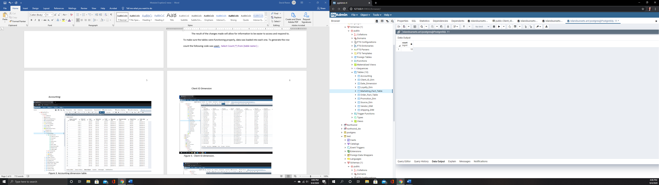

Order fact table is the heart of the system. It will be where most all of the research and analysis starts. This table contains all of the information on what was sold, how it was paid, who bought it, who shipped it, and when it arrived.

**Figure 12**

***Order Fact Table***

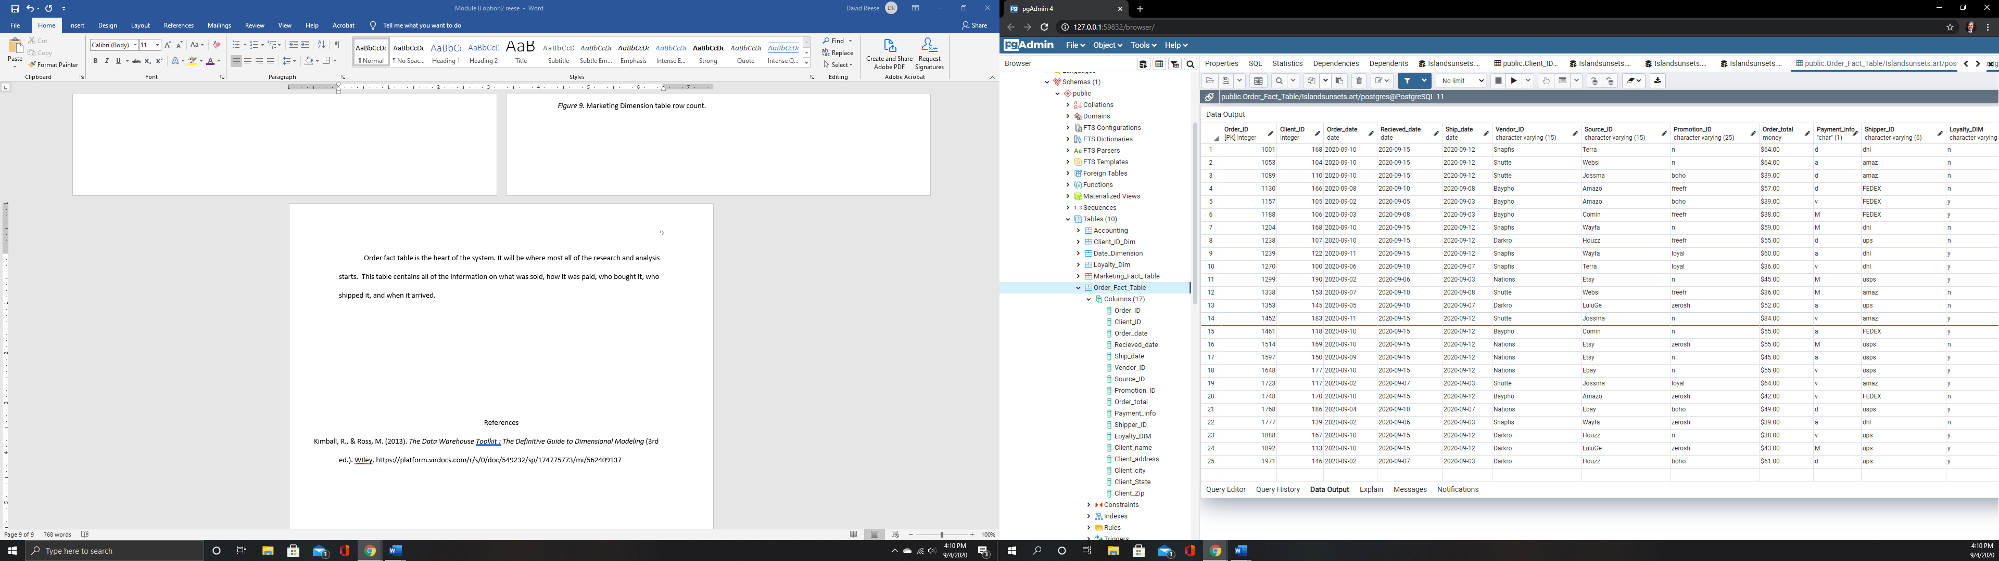

**Figure 13**

***Order Fact Table row count***

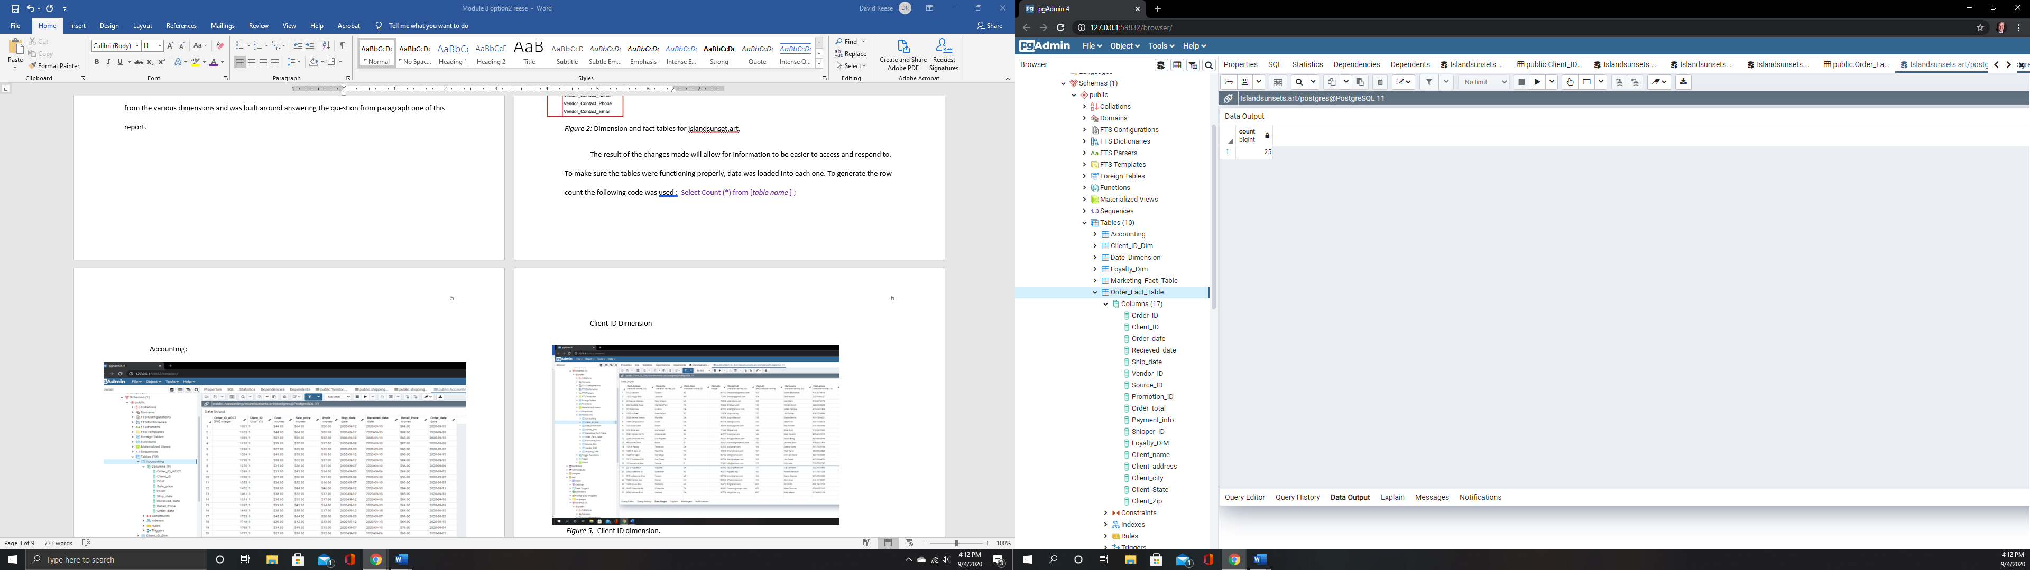

The promotion dimension table describes the various promotions offered by the company.

**Figure 14**

***Promotion Dimension Table with import success notification.***

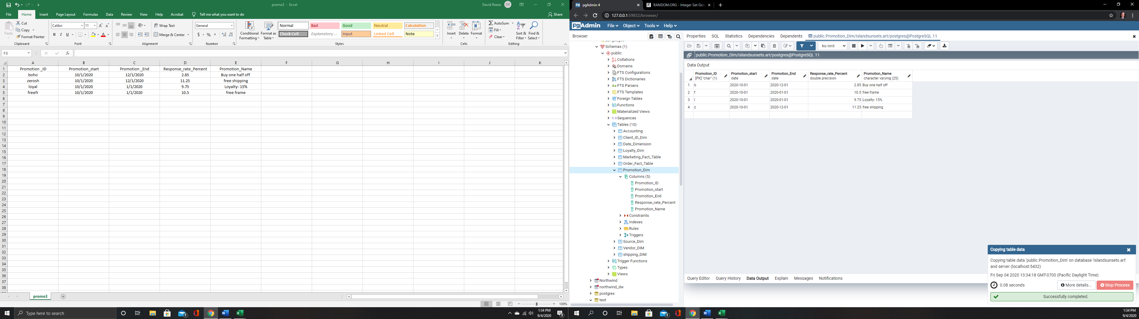

**Figure 15**

***Promotion Dimension table Row Count.***

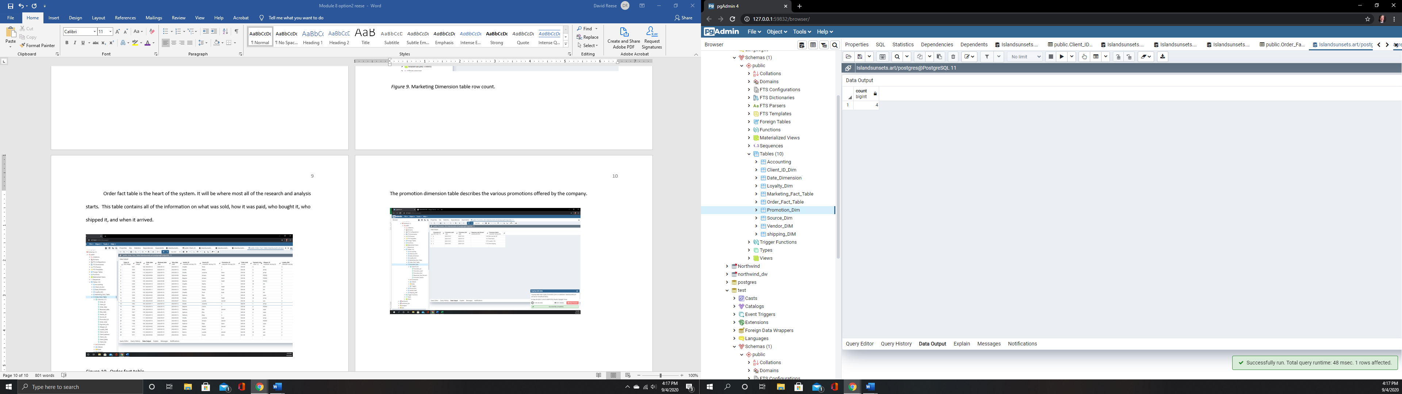

**Figure 16**

***Shipping Dimension Table.***

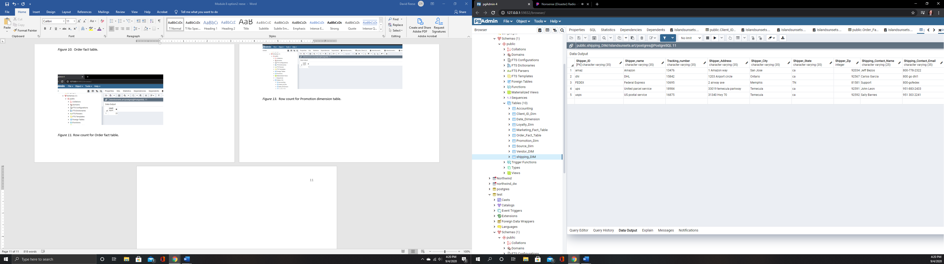

**Figure 17**

***Shipping Dimension Row Count***.

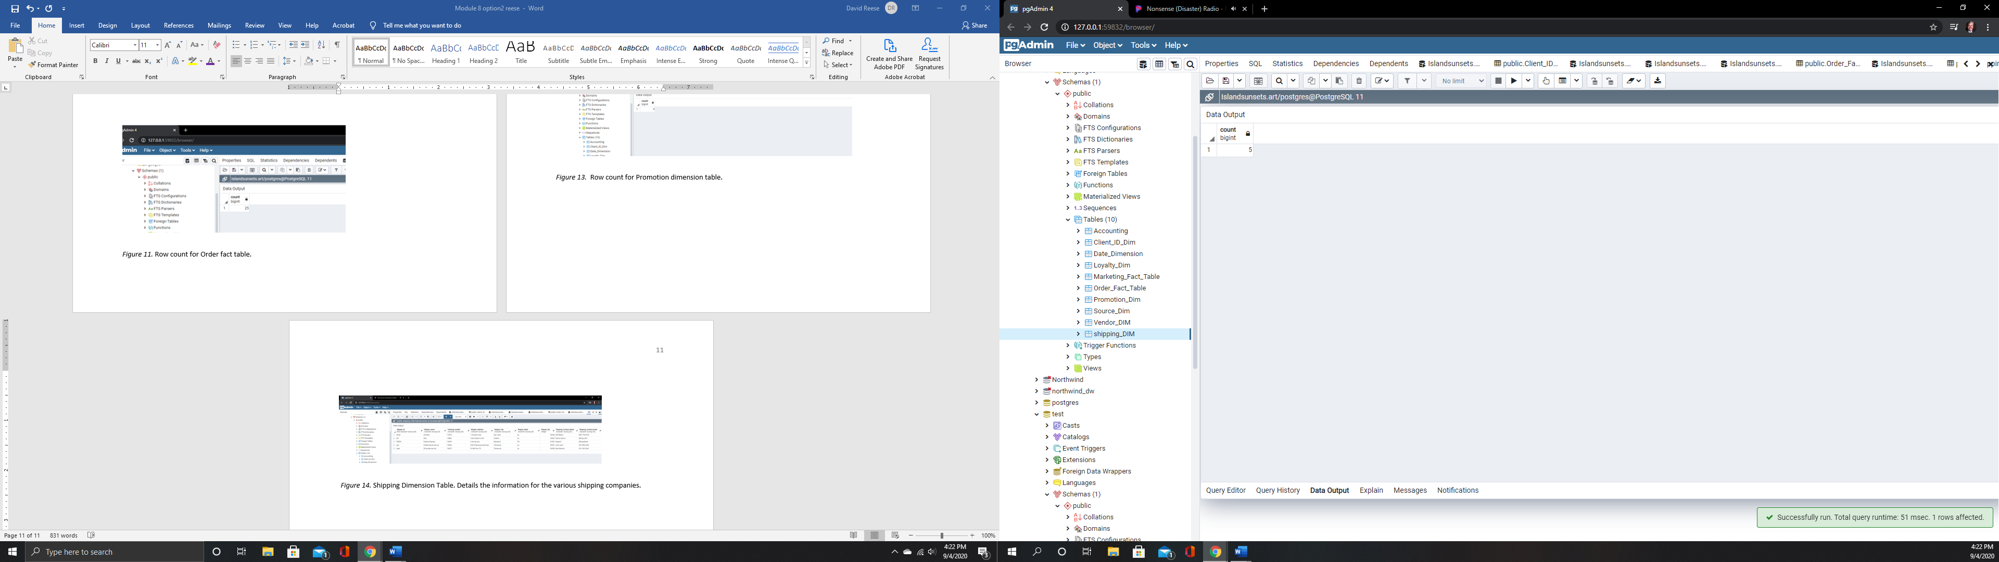

The source table details out the information for the various e-commerce companies the firm is working with to sell the images. It is important to know which are working and which aren’t since at launch time money will be tight. As the information in this table changes, it can be easily added to.

**Figure 18**

**Source Dimension Table Rows.**

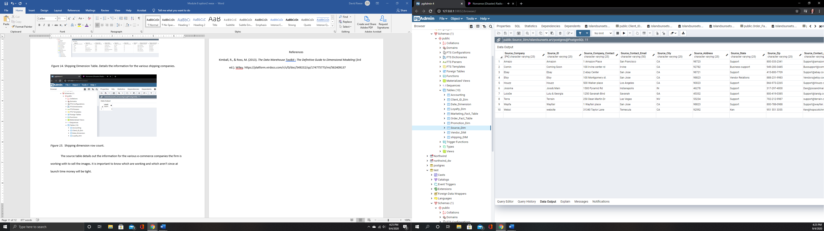

**Figure 19**

***Source Dimension Table Row Count***

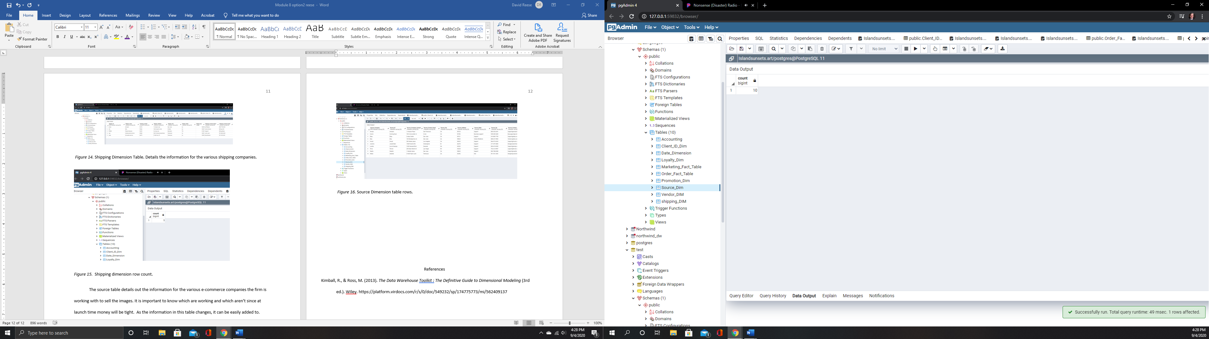

The vendor dimension table details the vendors and suppliers. This information will allow tracking of client satisfaction, and point the company towards the vendors who do not have quality issues. The company needs to make sure all of the partners understand they have a role in the success of the venture.

**Figure 20**

***Vendor Dimension Table****.*

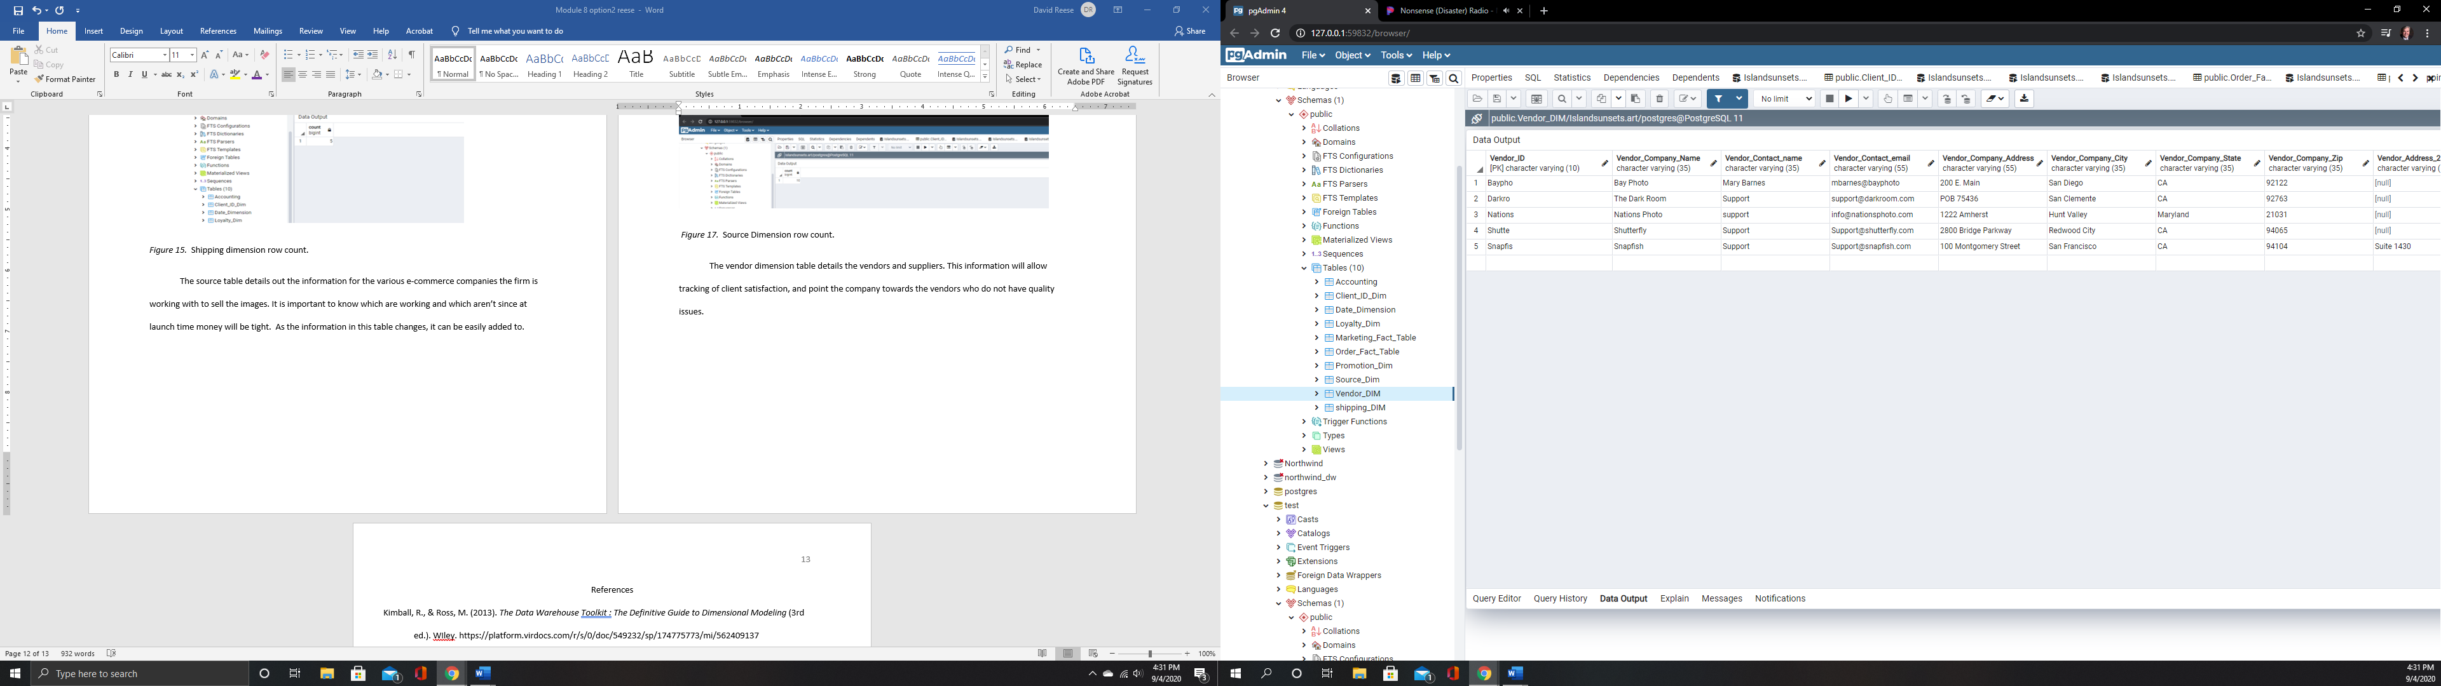

**Figure 21**

**Row Count for Vendor Dimension Table**

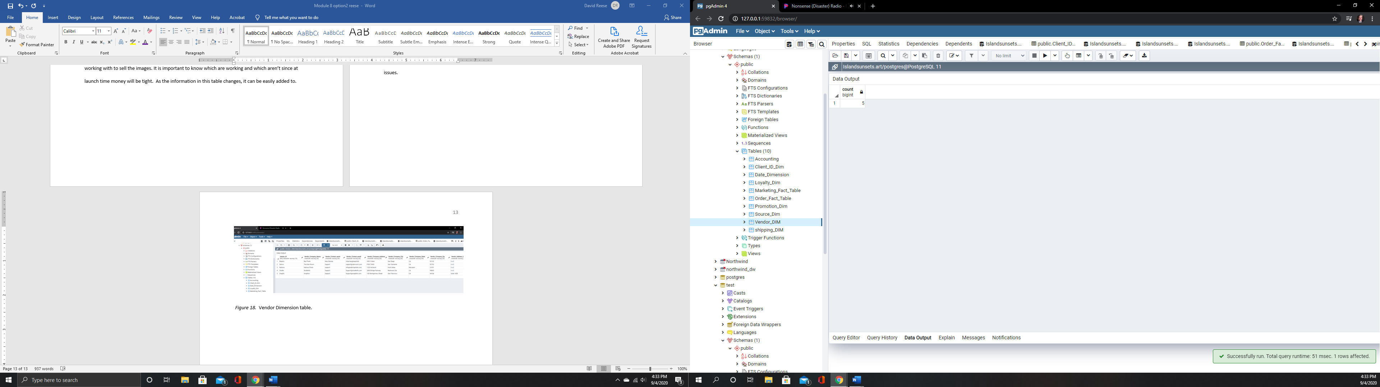

The experience of putting the data tables and dimensions has been very educational. The process can be overwhelming at first, until the people involved discover there is no right answer. There is a best answer, and will take a few attempts to find it. Be creative in how you rank the relative importance of various data. The data that is critical to some maybe seen as useless to others. Be willing to start over completely, frequently if needed. It is better to waste a sheet of paper than thousands on hardware.

Have the end in mind when you begin, and the trip goes faster. In designing this system, the goal was to know everything possible about our clients. It is possible to run a query on this system that will give me all of the information I need to process an order or research a shipment.

In terms of team and buy in for the process, set the expectation early and often that this is a good thing, for the employees and the company. It is vital for the overall survival of the company that data be easily accessible and secure. Make sure the expectation understood by the employees that everyone is responsible for keeping data secure, accurate, and clean.

References

Kimball, R., & Ross, M. (2013). *The Data Warehouse Toolkit: The Definitive Guide to Dimensional Modeling* (3rd ed.). WIley. https://platform.virdocs.com/r/s/0/doc/549232/sp/174775773/mi/562409137